1. Hahn Engineering's research and development group has identified five potential new engineering and development projects; however, the firm is constrained by its available budget and human resources. Each project is expected to generate a return (given by the net present value) but requires a fixed amount of cash and personnel. The resources are limited, and not all projects can be selected. Projects cannot be partially completed; the project must be undertaken completely or not at all. The data is given in the following table.

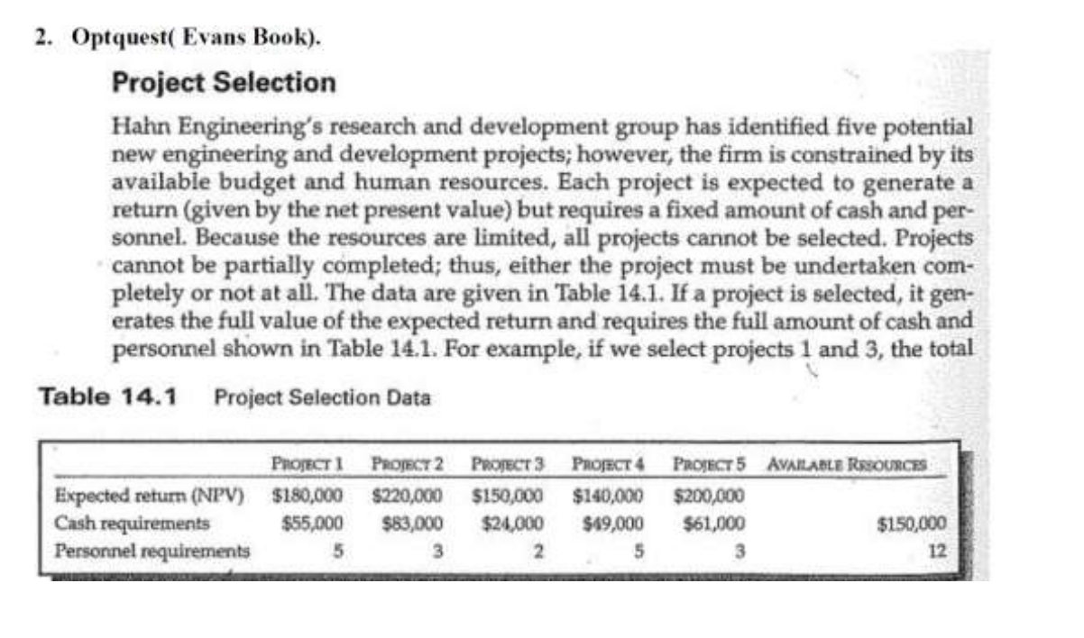

Suppose we want to ensure that if project 1 is selected, project 4 is also selected. Furthermore, at most, one of projects 1 and 3 can be selected.

Which projects should be selected to maximize profit?

2. Suppose an unincorporated village wishes to find the best locations for fire stations. Assume that the village is divided into smaller districts or neighborhoods and that transportation studies have estimated the response time for emergency vehicles to travel between each pair of districts. The village wants to locate the fire stations so that all districts can be reached within an 8-minute response time. The following table shows the estimated response time in minutes between each pair of districts.

|  |  |  |  |  |  |  |  |
| --- | --- | --- | --- | --- | --- | --- | --- |
| **From/To** | **1** | **2** | **3** | **4** | **5** | **6** | **7** |
| **1** | 0 | 2 | 10 | 6 | 12 | 5 | 8 |
| **2** | 2 | 0 | 6 | 9 | 11 | 7 | 10 |
| **3** | 10 | 6 | 0 | 5 | 5 | 12 | 6 |
| **4** | 6 | 9 | 5 | 0 | 9 | 4 | 3 |
| **5** | 12 | 11 | 5 | 9 | 0 | 10 | 8 |
| **6** | 5 | 7 | 12 | 4 | 10 | 0 | 6 |
| **7** | 8 | 10 | 6 | 3 | 8 | 6 | 0 |

Where should the fire stations be located to minimize the number of stations that need to be built?

3. Brewer Services contracts with outsourcing partners to handle various customer service functions. The customer service department is open Monday through Friday from 8 A.M. to 5 P.M. Calls vary over the course of a typical day. Based on a study of call volumes provided by one of the firm’s partners, the minimum number of staff needed each hour of the day are:

|  |  |
| --- | --- |
| Hour | Minimum Staff Required |
| 8-9 | 5 |
| 9-10 | 12 |
| 10-11 | 15 |
| 11-noon | 12 |
| noon-1 | 11 |
| 1-2 | 18 |
| 2-3 | 17 |
| 3-4 | 19 |
| 4-5 | 14 |

Mr. Brewer wants to hire some permanent employees and staff the remaining requirements using part-time employees who work four-hours shifts (four consecutive hours starting as early as 8A.M. or as late as 1 P.M.). Suppose that Mr. Brewer has five permanent employees. What is the minimum number of part-time employees he will need for each 4-hour shift to ensure meeting the staff requirements?